Analytics for the Australian Grains Industry - Curtin University (AAGI-CU)
Technical Report Series: 123
Descriptive title for report
Report for AAA–BBB
Prepared for: collab_partner (collab_partner@email.com.au)
Prepared by: Your.Name
Project Lead: Curtin University – Prof Mark Gibberd, Dr Julia Easton, Prof Adam Sparks
email: cbada@curtin.edu.au
October 10, 2024

Executive summary
What was provided by AAGI and the main results?

Introduction
- Goals of the research project.
- Background, context and rationale behind the research.

Experimental/Trial Design
- Trial design type and layout.
- Treatments, number of replicates.
- Specific considerations for small plots, glasshouse, genetics, breeding trials, OFE projects, or bioinformatics.

Exploratory Data Analysis and Data Visualisation
- Interpretation of plots and data.
- Rationale behind specific methods used.

Methods
- Detailed description of the procedures and methodologies used.
- Include versions/commits on developed pipelines, scripts, and input/output details if applicable.

Analysis (if separate from Methods)
Approach taken for data analysis.

Results and Discussion
Findings and their implications.

Figure example
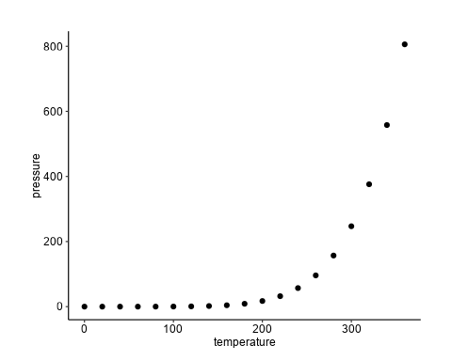
Figure 1: An example figure using {ggplot2}.

Table example
Table 1: An example table using {flextable}.
Ozone | Solar.R | Wind | Temp | Month | Day
41 | 190 | 7.4 | 67 | 5 | 1
36 | 118 | 8.0 | 72 | 5 | 2
12 | 149 | 12.6 | 74 | 5 | 3
18 | 313 | 11.5 | 62 | 5 | 4
 |  | 14.3 | 56 | 5 | 5
28 |  | 14.9 | 66 | 5 | 6

Metadata and Datasets (Optional)
- md5sums for input data and outputs (if applicable).
- Git commit numbers and tags.
- Location of outputs (FAIR Data).
- DOI for AAGI outputs.

Map (Location, Optional)
Include if relevant to the project.

References (Optional)
Cited works and literature. Box (1976)
Box, George E. P. 1976. “Science and Statistics.” Journal of the American Statistical Association 71 (356): 791–99. https://doi.org/10.1080/01621459.1976.10480949.

Appendix (Optional)
Additional supporting information.

